Section 1: Applicant & Project Details
Applicant’s Name: | Tipu Sultan | Student ID: | 2412434
Contact Email: | 2412434@iub.edu.bd | Mobile No: | 01811845553
Department: | EEE | School: | SET

Team Name: | EISight
Team Member 1 (if any) |  | Team Member 2 (if any)
Name: Sajidur Rahman Mahin |  | Name: Mir Erfan Kabir Rafi
ID: 2430832 |  | ID: 2411830
Department: EEE |  | Department: EEE

Project Title: | AI-Powered Low-Cost Electrical Impedance Spectroscopy with IoT for Rapid Food Adulteration Detection
Project Details: | EISight is developing a low-cost portable electrical impedance spectroscopy platform for food adulteration screening. Since the original proposal submission in October 2025, the execution scope has been refined from a broad contactless and multi-commodity concept to a milk-first, direct-contact, calibration-validated prototype with laptop-based inference. This revision was made after literature review, simulation-based feasibility analysis, and domain-shift assessment showed that repeatable physical measurement must take priority over interface polish or broad claims. The current phase has completed literature synthesis, system architecture design, a synthetic-data feasibility study, methodology revision for real-world acquisition, and hardware procurement planning. The next phase focuses on AD5933-ESP32 integration, resistor and liquid-cell calibration, pure milk repeatability testing, and the transition from simulated spectra to physical measurements.
Supervisor Name & Designation: | Dr. Feroz Ahmed, Professor, Department of EEE

Section 2: Progress Update (December 2025 – Present)
Summary of Activities Completed:

- Literature Review:
An IEEE-style literature review was completed to establish the technical foundation of the project. The review showed that EIS is an information-rich and non-destructive sensing method, that portable AD5933-class hardware is feasible but calibration-dependent, and that milk-focused EIS studies already report strong discrimination under controlled laboratory conditions. The same review also clarified that the main unresolved problems are field reliability, especially calibration, temperature sensitivity, preprocessing, and matrix variability rather than basic proof that EIS can respond to adulteration.
- Scope Refinement and Feasibility Analysis:
The original proposal described a wider system vision that included contactless sensing, multiple food categories, IoT connectivity, and a broader field-deployment narrative. During the current phase, that scope was refined and its implementation sequence was staged for methodological rigor. The execution path is now milk-first, direct-contact, calibration-validated, and laptop-based, with edible oil retained as a secondary extension only after milk repeatability is confirmed. Contactless sensing, mobile-app integration, TinyML deployment, and cloud connectivity remain part of the planned system development for the current AURA cycle; however, the present phase prioritizes calibration-validated direct-contact measurement, repeatable real-data acquisition, and reliable baseline inference before these advanced extensions are finalized.
- System Architecture Design:
The hardware and software architecture was finalized at the design level. The baseline instrument stack is an AD5933 impedance measurement stage interfaced to an ESP32-class controller, a fixed-geometry direct-contact liquid cell for milk measurements, temperature logging, USB serial transfer to a laptop, and a local Python inference pipeline intended for a Streamlit-based demonstration. This replaces the earlier emphasis on browser/mobile-first deployment and places measurement repeatability, calibration, and debugging convenience at the center of the prototype plan.
- Synthetic-Data Feasibility Study:
A reviewed canonical simulation pipeline was completed and run in simulation mode to test the end-to-end ML workflow before hardware arrival. Using the canonical summary file only, the synthetic Cole-Cole feasibility study produced 5-fold multiclass F1 scores of 0.9867 for Gradient Boosting, 0.9933 for Random Forest, and 0.9956 for SVM-RBF. For binary pass/fail classification, the same simulated pipeline produced F1 scores of 0.9955 for Gradient Boosting and 1.0000 for SVM-RBF. These are synthetic feasibility results, not empirical hardware data, and they are used only to justify the plausibility of the planned feature-extraction and classification approach.

The simulation pipeline, generated figures, and supporting project documents are being maintained in a GitHub repository for version control, reproducibility, and team coordination. Project repository: [https://github.com/2412434-tipu/EISight]

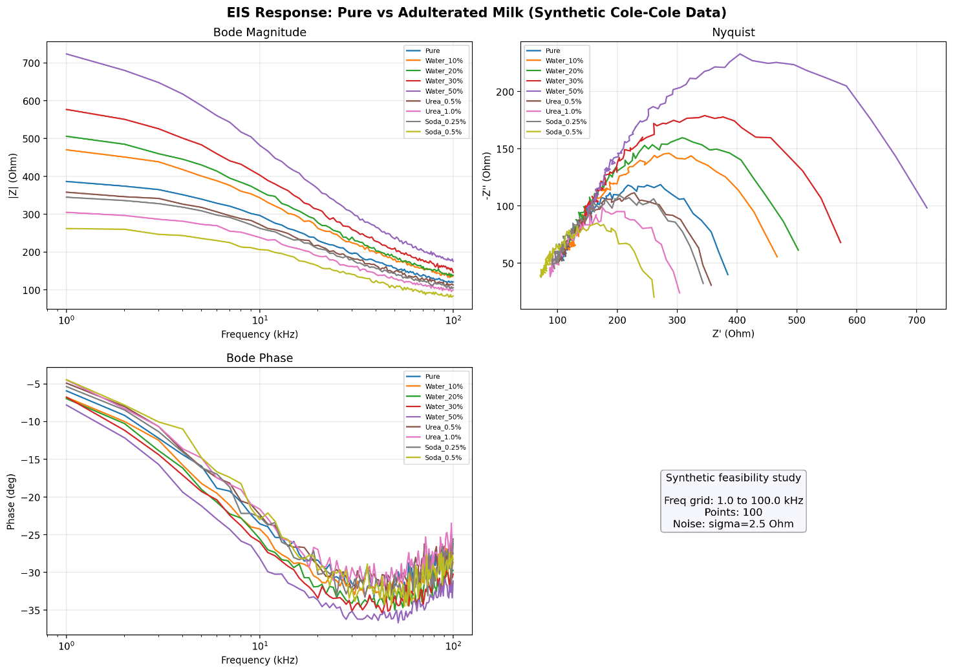
Figure 1: Simulated EIS spectra (Bode magnitude, Nyquist plot, and phase response) for pure and adulterated milk generated from the synthetic Cole-Cole feasibility study. This figure is illustrative of the simulated response space and is not based on hardware measurements.
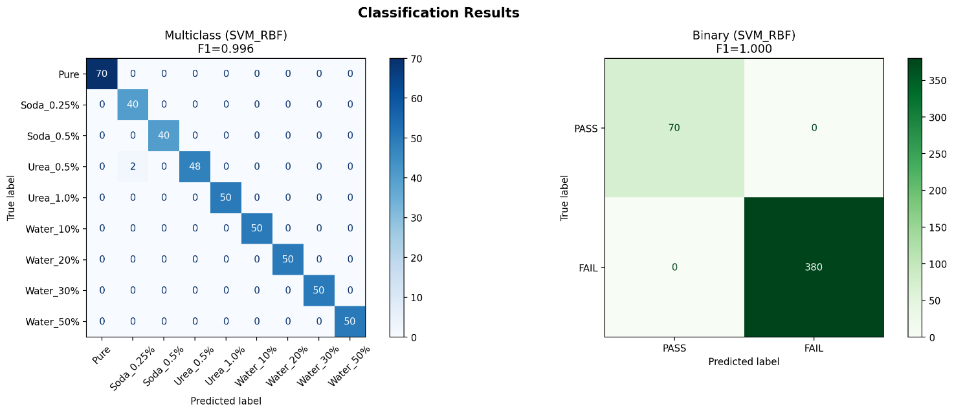
Figure 2: Confusion matrices from the synthetic-data ML feasibility study. Multiclass SVM-RBF F1 = 0.9956 and binary pass/fail SVM-RBF F1 = 1.0000. These are simulated feasibility results, not empirical hardware results.

- Methodology Revision Based on Domain-Shift Risk Analysis:
The project methodology was revised after identifying a serious simulation-to-reality gap. The updated plan now requires per-session calibration against known references, empirical temperature correction derived from measured data rather than a fixed simulated coefficient, sweep-rejection quality control for unstable or distorted measurements, day-grouped validation to prevent leakage from within-day drift, same-day control normalization, and strict metadata logging for sample condition and acquisition context. This revision changed the project from a simulation-led software exercise into an instrumentation-led experimental program, which is the correct direction for a defensible EIS study on conductive liquid food samples.

- Hardware Procurement:
AD5933 breakout modules and ESP32 microcontrollers are being sourced from China through an international purchase channel because the AD5933 is not available in Bangladeshi electronics markets. Local procurement has started for supporting items such as temperature sensors, electrode materials, and precision calibration resistors. Hardware integration and real data collection have therefore not yet begun, but procurement planning and readiness work have been completed.

Current Completion Percentage:
- 0-25% (Just Started)
Justification: Theoretical groundwork, architecture design, simulation, and methodology revision have been completed, but hardware integration and empirical data collection have not yet started.

Section 3: Challenges & Solutions
Challenges Encountered:
- Component unavailability in Bangladesh
The AD5933 impedance analyzer IC and ready-to-use modules were not available in local Bangladeshi electronics markets. This delayed the start of hardware prototyping and prevented empirical measurements during the reporting period.

- Scope overreach in the original proposal
The original proposal outlined a broader system vision that included contactless sensing, multi-commodity validation, and smartphone-oriented inference. During implementation, the project scope was refined to prioritize calibration, repeatability, and real-data validation on milk as the primary benchmark. These additional components are still planned within the AURA cycle, but they are being developed in a staged manner around the core sensing workflow.

- Simulation-to-reality domain shift
Review of the original simulation-oriented workflow showed that generic temperature correction and basic smoothing were not sufficient for real AD5933 measurements on conductive liquid food samples. Calibration drift, electrode effects, temperature dependence, and measurement instability would have made a direct “swap-in” of real data scientifically weak.

How were these challenges resolved?
- International sourcing was initiated for the AD5933 modules and related components, with delivery expected in early April. Local procurement was used for all supporting parts that could be obtained inside Bangladesh.
- The implementation sequence was refined to prioritize a milk-first, direct-contact, calibration-validated prototype while continuing broader features in staged development. Edible oil remains a secondary target, and contactless sensing, mobile-app integration, TinyML, and cloud connectivity continue to be pursued within the current AURA cycle without taking priority over core measurement validation.
- The pipeline methodology was revised before hardware arrival to include calibration correction, empirical temperature compensation, sweep-rejection quality control, day-grouped validation, blank/control normalization, and structured metadata logging. This reduces the risk of building a misleading classifier from unstable measurements.

Section 4: Roadmap to Final Presentation (March – June 2026)
Monthly Deliverables Plan:

March:

March was used mainly for literature review completion, proposal-to-execution scope refinement, synthetic-data simulation, ML pipeline review, hardware sourcing, and preparation of the present progress report. Active bench work was intentionally limited during this period. This stage was also used to organize the implementation sequence so that core sensing validation remains the first priority while broader system components continue to be planned for the current AURA cycle.

April:

Hardware arrival, breadboard assembly of the AD5933 and ESP32 chain, and initial firmware bring-up will be the main priorities. The month will focus on resistor calibration using 100 ohm, 1 kilo-ohm, and 10 kilo-ohm references, fabrication of a fixed-geometry liquid cell, within-session and across-session repeatability tests on DI water and pure UHT milk, and definition of the trusted frequency sub-band. Temperature characterization will also be performed on the same milk sample at controlled temperature points. If pure milk is not repeatable, hardware debugging will take priority over adulteration data collection. Broader system features such as mobile-app integration and cloud connectivity are documented in the project architecture but will not be prioritized until the core measurement chain is validated.

May:

Real milk adulteration data collection will begin with water dilution only, using controlled concentration levels across at least three separate days. Urea and baking soda classes will be attempted only if the water-dilution baseline is stable and repeatable. The real-data phase will include calibration-aware preprocessing, grouped validation, model retraining, and development of a local Streamlit demonstration in which the ESP32 streams data over USB serial to a laptop-based inference pipeline. Blind-sample testing prepared by another team member is planned after the first stable dataset is obtained. Smartphone interfacing, cloud-linked operation, and embedded inference remain planned extensions that will be pursued only after the core milk-detection workflow produces stable, repeatable results.

June:

The final month will be used for prototype refinement, stress testing under realistic operating variations, poster preparation, presentation rehearsal, and AURA demonstration readiness. A small pilot edible-oil appendix may be attempted only if the milk workflow is already stable and repeatable. Milk remains the primary validation target for the final presentation. If the milk prototype is stable by mid-June, a limited pilot on edible oil or a basic mobile interface may be attempted as a secondary demonstration. The primary AURA deliverable remains the calibrated, repeatable, milk-focused EIS screening prototype with laptop-based inference.

Section 5: Support & Resources
Is there any specific non-financial support required from IUB?
Yes. We request: Lab Access; Hardware/Components; Expert/Faculty Guidance. No additional Software/Data Access request is being made at this stage.
If yes, please specify further details:
- Lab Access
Temporary access to an EEE laboratory bench is required for AD5933 testing, precision-resistor calibration, and controlled milk measurements. Access to an oscilloscope and function generator would help verify excitation integrity, signal behavior, and calibration accuracy during early hardware characterization.

- Hardware/Components
Loan access to an AD5933 evaluation board such as the EVAL-AD5933EBZ, or an equivalent impedance-analysis platform if one exists within IUB, would accelerate calibration and benchmarking. Support in facilitating procurement through any available AURA or departmental channel for AD5933 modules, ESP32 boards, electrode materials, precision calibration resistors, and basic sample-handling consumables would also help the project move from simulation to physical testing more quickly.

- Expert/Faculty Guidance
Periodic guidance from Dr. Feroz Ahmed is needed on electrode design, embedded measurement validation, and experimental methodology review.

Section 6: Declaration
As supervisor of this project I, ____________________ , have checked the information provided in this form and found it to be true.

____________________
Signature of Supervisor

*NB: After filling out the whole progress report, Please get the signature from the Supervisor of your project.

